## What is Entity Framework?

ADO.NET entity is an ORM (object relational mapping) which creates a higher abstract object model over ADO.NET components. So rather than getting into dataset, datatables, command, and connection objects as shown in the below code, you work on higher level domain objects like customers, suppliers, etc.

DataTable table = adoDs.Tables[0];

for (int j = 0; j < table.Rows.Count; j++)

{

DataRow row = table.Rows[j];

*// Get the values of the fields*

string CustomerName =

(string)row["Customername"];

string CustomerCode =

(string)row["CustomerCode"];

}

Below is the code for Entity Framework in which we are working on higher level domain objects like customer rather than with base level ADO.NET components (like dataset, datareader, command, connection objects, etc.).

foreach (Customer objCust in obj.Customers)

{}

## What are the benefits of using EF?

The main and the only benefit of EF is it auto-generates code for the Model (middle layer), Data Access Layer, and mapping code, thus reducing a lot of development time.

## What are the different ways of creating these domain / entity objects?

Entity objects can be created in two ways: from a database structure, or by starting from scratch by creating a model.

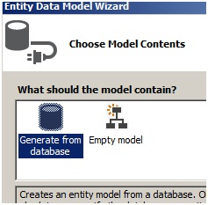

## What is pluralize and singularize in the Entity Framework dialog box?

“Pluralize” and “Singularize” give meaningful naming conventions to objects. In simple words it says do you want to represent your objects with the below naming convention:

* One Customer record means “Customer” (singular).
* Lot of customer records means “Customer’s” (plural, watch the “s”)

If you select the below checkbox, Entity Framework generates a naming convention which adheres to plural and singular coding conventions.

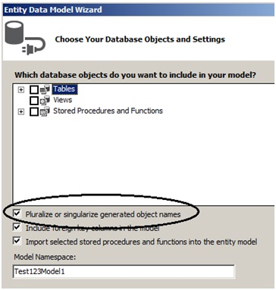

## What is the importance of EDMX file in Entity Framework?

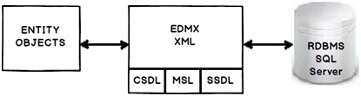

EDMX (Entity Data Model XML) is an XML file which contains all the mapping details of how your objects map with SQL tables. The EDMX file is further divided into three sections: CSDL, SSDL, and MSL.

## Can you explain CSDL, SSDL and MSL sections in an EDMX file?

* CSDL (Conceptual Schema definition language) is the conceptual abstraction which is exposed to the application.
* SSDL (Storage Schema Definition Language) defines the mapping with your RDBMS data structure.
* MSL (Mapping Schema Language) connects the CSDL and SSDL.

CSDL, SSDL and MSL are actually XML files.

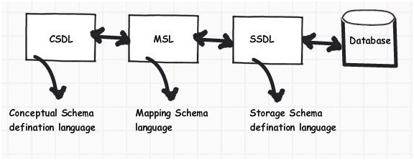

***Figure: CSDL, MSL, and SSDL***

## What are T4 templates?

T4 (Text Template Transformation Toolkit) is a template based code generation engine. You can go and write C# code in T4 templates (.tt is the extension) files and those C# codes execute to generate the file as per the written C# logic.

For instance, the below T4 C# code:

<#@ template language="“C#”" #>

Hello <# Write(”World!”) #>

Will generate the following C# output:

Hello

World !

## What is the importance of T4 in Entity Framework?

T4 files are the heart of EF code generation. The T4 code templates read the EDMX XML file and generate C# behind code. This C# behind code is nothing but your entity and context classes.

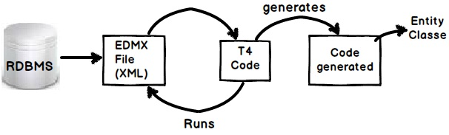

If you create a project using VS 2012, you will see the following hierarchy. At the top we have the EDMX file, followed by the TT or T4 file, and then the .CS code file.

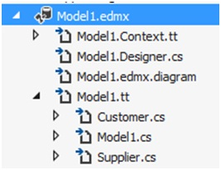

## How can we read records using Entity Framework classes?

In order to browse through records you can create the object of the context class and inside the context class you will get the records.

For instance, in the below code snippet we are looping through a customer object collection. This customer collection is the output given by the context class CustomermytextEntities.

CustomermytestEntities obj = new CustomermytestEntities();

foreach (Customer objCust in obj.Customers)

{}

## How can we add, update, and delete using EF?

Create the object of your entity class, add it to the data context using AddObject method, and then call theSaveChanges method.

CustomermytestEntities obj = new CustomermytestEntities();

Customer objCust = new Customer();

objCust.CustomerCode = "1001";

obj.Customers.AddObject(objCust);

obj.SaveChanges();

If you want to update, select the object, make changes to the object, and call AcceptAllChanges.

CustomermytestEntities objContext = new CustomermytestEntities();

Customer objCustomer = (Customer)objContext.Customers.FirstOrDefault();

objCustomer.CountryCode = "NEP";

objContext.AcceptAllChanges();

If you want to delete, call the DeleteObject method as shown in the below code snippet:

CustomermytestEntities objContext = new CustomermytestEntities();

Customer objCustomer = (Customer)objContext.Customers.FirstOrDefault();

objContext.DeleteObject(objCustomer);

## People say Entity Framework runs slow

By default EF has lazy loading behavior. Due to this default behavior if you are loading a large number of records and especially if they have foreign key relationships, you can have performance issues. So you need to be cautious if you really need lazy loading behavior for all scenarios. For better performance, disable lazy loading when you are loading a large number of records or use stored procedures.

## Can you explain lazy loading in a detailed manner?

Lazy loading is a concept where we load objects on demand rather than loading everything in one go. Consider a situation where you have 1 to many relationships between the Customer and Address objects. Now let’s say you are browsing the customer data but you do not want address data to be loaded at that moment. But the time you start accessing the address object you would like to load address data from the database.

Entity Framework has lazy loading behavior by default enabled. For instance, consider the below code. When we are doing a foreach on the Customer object, the Address object is not loaded. But the time you start doingforeach on the address collection, the Address object is loaded from SQL Server by firing SQL queries.

So in simple words, it will fire a separate query for each address record of the customer, which is definitely not good for a large number of records.

MyEntities context = new MyEntities();

var Customers = context.Customers.ToList();

foreach (Customercust in Customers) // In this line no address object loaded

{

foreach(Address add in cust.Addresses){}// Address object is loaded here

}

## How can we turn off lazy loading?

The opposite of lazy loading is eager loading. In eager loading we load the objects beforehand. So the first thing is we need to disable lazy loading by setting LazyLoadingEnabled to false.

context.ContextOptions.LazyLoadingEnabled = false;

Now we have to explicitly tell EF what objects we want to load by using the include function. Below is a simple sample code where we tell EF to load customer as well as address objects by using the include function.

Now the customer object and the related address objects will be loaded in one query rather than multiple queries.

var employees = context.Customers.Include("Addresses").Take(5);

## How can we use stored procedures in Entity Framework?

You can use stored procedure mapping details in EDMX as shown in the below figure.

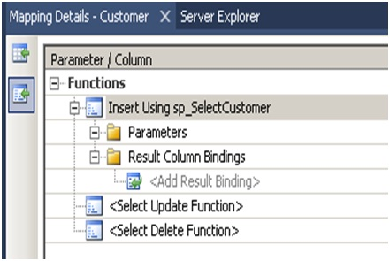

***Figure: Specify stored procedures***

## What are POCO classes in Entity Framework?

POCO means Plain Old C# Object. When EDMX creates classes, they are cluttered with a lot of entity tags. For instance, below is a simple customer class generated using Entity Framework. Many times we would like to use simple .NET classes and integrate them with Entity Framework.

Entity Framework allows this. In other words you can create a simple .NET class and use the entity context object to load your simple .NET classes.

Below is a simple class generated by EF which is cluttered with a lot of EF attributes.

[EdmEntityTypeAttribute(NamespaceName="CustomermytestModel", Name="Customer")]

[Serializable()]

[DataContractAttribute(IsReference=true)]

public partial class Customer : EntityObject

{

#region Factory Method

/// *<summary>*

/// *Create a new Customer object.*

/// *</summary>*

/// *<param name="id" />Initial value of the Id property.*

/// *<param name="customerCode" />Initial value of the CustomerCode property.*

/// *<param name="customername" />Initial value of the Customername property.*

public static Customer CreateCustomer(global::System.Int32 id,

global::System.String customerCode, global::System.String customername)

{

Customer customer = new Customer();

customer.Id = id;

customer.CustomerCode = customerCode;

customer.Customername = customername;

return customer;

}

#endregion

#region Primitive Properties

## How do we implement POCO in Entity Framework?

To implement POCO is a three step process:

Go to the designer and set the code generation strategy to NONE. This step means that you would be generating the classes on your own rather than relying on EF auto code generation.

Now that we have stopped the auto generation of code, we need to create the domain classes manually. Add a class file and create the domain classes like the Customer class we created.

public class Customer

{

private string _customerName;

public string CustomerName

{

get { return _customerName; }

set { _customerName = value; }

}

private int _Customerid;

public int Customerid

{

get { return _Customerid; }

set { _Customerid = value; }

}

}

* Write your Context layer code inheriting from ObjectContext. This code you can copy paste from the behind code of EF, also before disabling auto-generation.

public partial class Test123Entities : ObjectContext

{

public Test123Entities(): base("name=Test123Entities", "Test123Entities")

{

this.ContextOptions.LazyLoadingEnabled = true;

OnContextCreated();

}

partial void OnContextCreated();

public ObjectSet<Customer> Customers

{

get

{

if ((_Customers == null))

{

_Customers = base.CreateObjectSet<Customer>("Customers");

}

return _Customers;

}

}

private ObjectSet<Customer> _Customers;

public void AddToCustomers(Customer customer)

{

base.AddObject("Customers", customer);

}

}

And finally you can use the above code in your client as if you where using EF normally.

Test123Entities oContext = new Test123Entities();

List<Customer> oCustomers = oContext.Customers.ToList<Customer>();

## In POCO classes do we need EDMX files?

Yes, you will still need EDMX files because the context object reads the EDMX files to do the mapping.

## What is Code First approach in Entity Framework?

In Code First approach we avoid working with the Visual Designer of Entity Framework. In other words the EDMX file is excluded from the solution. So you now have complete control over the context class as well as the entity classes.

## What the difference is between POCO, Code First, and simple EF approach?

All these three approaches define how much control you want on your Entity Framework code. Entity Framework is an OR mapper, it generates a lot of code, it creates your middle tier (Entity), and Data Access layer (Context).

But a lot of times you want to enjoy the benefits of both worlds, you want the auto-generation part to minimize your development time and you want control on the code so that you can maintain code quality.

Below is the difference table which defines each of the approaches. In simple Entity Framework, everything is auto generated and so you need the EDMX XML file as well. POCO is semi-automatic so you have full control on the entity classes but then the context classes are still generated by the EDMX file.

In Code First, you have complete control on how you can create the entity and context classes. Because you are going to manually create these classes, you do not have dependency on the EDMX XML file. Below is a simple table which shows the cross comparison.

|  | **EDMX** | **Entity** | **Context** |
| --- | --- | --- | --- |
| **Simple entity framework** | Needed | Auto | Auto |
| **POCO approach** | Needed | Manual | Auto |
| **Code First** | Not Needed | Manual | Manual |

## How can we handle concurrency in Entity Framework?

**Note**: Before this question, the interviewer can ask you about concurrency and what is pessimistic and optimistic locking. Please do refer to the ADO.NET chapter for those.

In EF, concurrency issue is resolved by using optimistic locking. Please refer to the ADO.NET chapter for what is optimistic locking and pessimistic locking? To implement optimistic locking, right click on the EDMX designer and set the concurrency mode to Fixed, as shown in the below figure.

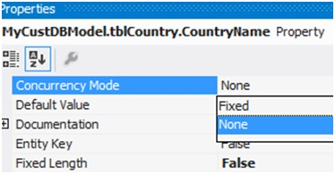

Now whenever we have concurrency issues you should get an OptimisticConcurrencyException error as shown in the below figure. You can then put a try / catch to handle this situation.

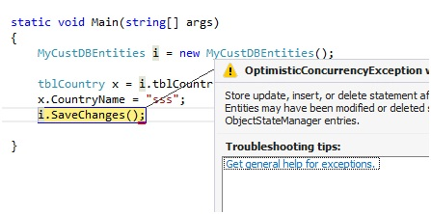

## How can we do pessimistic locking in Entity Framework?

We cannot do pessimistic locking using Entity Framework. You can invoke a stored procedure from Entity Framework and do pessimistic locking by setting the isolation level in the stored procedure. But directly, Entity Framework does not support pessimistic locking.

## What is client wins and store wins mode in Entity Framework concurrency?

Client wins and store wins are actions which you would like to take when concurrency happens. In store wins / database wins, the data from the server is loaded into your entity objects. Client wins is opposite to stored wins, data from the entity object is saved to the database.

We need to use the Refresh method of the Entity Framework context and provide the RefreshMode enum values. Below is a simple code snippet which executes ClientWins.

Context.Refresh(System.Data.Objects.RefreshMode.ClientWins,Obj);

## What are scalar and navigation properties in Entity Framework?

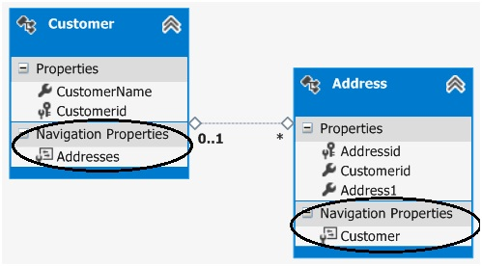

Scalar properties are those where actual values are contained in the entities. For example, in the above customer entity, customername and customerid are scalar properties. Normally a scalar property will map to a database field.

Navigation properties help to navigate from one entity to another entity. For instance, consider the below example in which we have two entities: Customer and Address, and a customer has multiple address objects.

Now we would like to have a facility where at any given moment we would like to browse from a given customer object to the addresses collection and from the address object to the customer.

If you open the Entity Designer, you would notice navigation properties as shown below. The navigation properties are automatically created from the primary and foreign key references.

So now because of those navigation properties, we can browse from the Customer to the Addresses object, look at the below code:

Customer Cust = oContext.Customers.ToList<Customer>()[0];

// From customer are browsing addresses

List<Address> Addresses = Cust.Addresses.ToList<Address>();

You can also do vice versa. In other words, from the Address object, you can reference the Customer object, as shown in the below code.

Address myAddress = Addresses[0];

// From address we can browse customer

Customer cus = myAddress.Customer;

## What are complex types in Entity Framework?

There can be situations where you have common properties across entities. For example, consider the below figure where we have Customer and Supplier entities. They have three fields in common: Address1,Address2, and PhoneNo. These fields have been duplicated both in the Customer and Supplier entities.

So to remove these duplicate and redundant fields, we can move them to a common complex type calledAddress. Complex types group common fields so that they can be reused across entities.

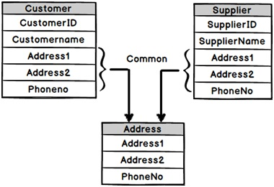

To create a complex type, select the fields which you want to group in a complex type, click on Refactor, and create the complex type. Below is a figure which shows this. Once the complex type is created, you can then reuse the complex type with other entities as well.

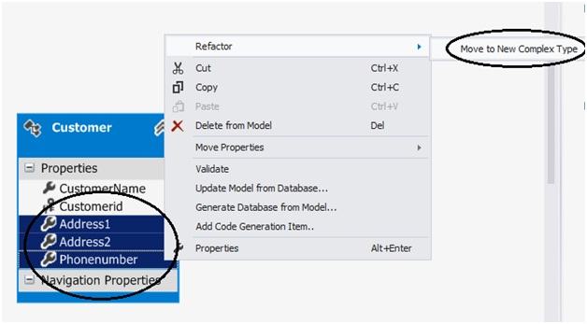

## What’s the difference between LINQ to SQL and Entity Framework?

* LINQ to SQL is good for rapid development with SQL Server. EF is for enterprise scenarios and works with SQL Server as well as other databases.
* LINQ maps directly to tables. One LINQ entity class maps to one table. EF has a conceptual model and that conceptual model maps to the storage model via mappings. So one EF class can map to multiple tables, or one table can map to multiple classes.
* LINQ is more targeted towards rapid development while EF is for enterprise level where the need is to develop a loosely coupled framework.

## What is the difference between DbContext and ObjectContext?

DbContext is a wrapper around ObjectContext, it’s a simplified version of ObjectContext.

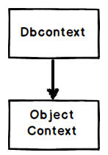

As a developer you can start with DbContext as it’s simple to use. When you feel that some of the operations cannot be achieved by DbContext, you can then access ObjectContext from DbContext, as shown in the below code:

((IObjectContextAdapter)dbContext).ObjectContext

Note: If the interviewer asks what kind of operations are not supported in DbContext, you can excuse by saying you do not remember them up front. Wonder why sometimes interviewers ask API level questions?

## Mention what is the key advantage of using Entity Framework or EF?

The main advantage of using Entity Framework or EF is that it generates code automatically for the Model (Middle Layer), Mapping code and Data Access Layer. It reduces a lot of time during the development process.

## Mention in what all scenarios Entity Framework can be applicable?

Entity Framework can be applicable in three scenarios

* If you have existing database already or you want to build your database first than other parts of the application
* If your prime focus is your domain classes and then create the database from your domain classes
* If you want to design your database schema on the visual designer and create the classes and database

## Explain what does .edmx file contains?

.edmx file is an XML file, which declares a conceptual model, a storage model and the mapping between these models.  This file also consists the information that is used by ADO.NET entity data model designer to render a model graphically. It consists of all the mapping details of how object maps with SQL tables.  It is divided into three categories SSDL, CSDL, and MSL.

## Mention what is CSDL, SSDL and MSL sections in an EDMX file?

* CSDL: It stands for Conceptual Schema Definition Language, it is the conceptual abstraction which is exposed to the application
* SSDL: It stands for Storage Schema Definition Language, it defines the mapping with our RDBMS data structure
* MSL: It stands for Mapping Schema Language, it connects the SSDL and CSDL

[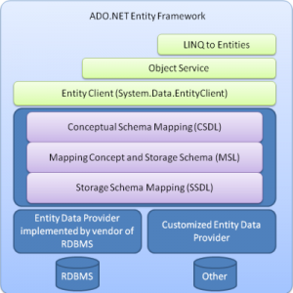](http://career.guru99.com/wp-content/uploads/2015/01/ADO_NET_Entity_Framework_Architecture.png)

## Mention what is the difference between LINQ to SQL and Entity Framework?

|  |  |
| --- | --- |
| LINQ to SQL | Entity |
| It works only with SQL Server Database  To maintain the relation it generates a .dbml  It cannot generate database from model  It permits one to one mapping between the entity classes and relational views/tables  It enables you to query data using DataContext  It provides tightly coupled approach | It works with various database like DB2, MYSQL, SQL Server etc.  It creates an .edmx files initially and relation is maintained using 3 different files .msl, .csdl and .ssdl  It can generate database from model  Between the entity classes and relational tables, it permits one-to-one, one-to-many and many-to-many  It enables you to query data using EntitySQL, DBContext, and ObjectContext  It provides loosely coupled approach |

## How can you enhance the performance of Entity Framework?

To enhance the performance of Entity Framework, you have to follow the following steps

* Try to avoid to put all the DB objects into one single entity model
* Disable change tracking for entity if not needed
* Reduce response time for the first request by using pre-generating Views
* If not required try to avoid fetching all the fields
* For data manipulation select appropriate collection
* Wherever needed use compiled query
* Avoid using Views and Contains
* While binding data to grid or paging, retrieve only required no of records
* Debug and Optimize LINQ query

## Explain how you can load related entities in EF (Entity Framework)?

You can load related entities or data in EF in three ways

* Eager Loading
* Lazy Loading
* Explicit Loading

## Mention what is Code First approach and Model First Approach in Entity Framework?

* Model First Approach: In this approach we create entities, relationships directly on the design surface of EDMX.
* Code Approach: For code approach we avoid working with the visual designer or entity framework.

## Explain Lazy loading, Eager Loading, and Explicit Loading?

* Lazy Loading: It is a process to delay the loading of related objects until it is required.
* Eager Loading: It occurs when you query for an object and all of the related objects are also returned. In eager loading, related objects are loaded automatically with its parent object
* Explicit Loading: Explicitly loading takes place when you have disabled Lazy loading, and you still want to lazy loading. For this, we have to call the load method on the related entities.

## Mention what is the difference between ADO.NET and classic ADO?

* In NET, we have data-set while ADO we have record-set
* In record-set we can only have one table and to insert more than one table you have to do inner join. While the dataset in ADO.NET can have multiple tables
* In NET, all data persist in XML while in classic ADO the data persists in binary format also

## What is the namespace used to include .NET Data provider for SQL server in .NET code?

The namespace System.Data.SqlClient is used to include.NET data provider for SQL server in .NET code.

## Mention what are the various methods provided by the DataSet object to generate XML?

To generate XML various DataSet object include

* ReadXml () : It reads XML document into DataSet object
* GetXml () : It returns string consisting an XML document
* Write Xml () : It writes an XML data to disk

## Mention what is DataAdapter class in ADO.NET?

In ADO.NET data-adapter class fetch data from the database, stores data in a dataset and reflects the changes made in the dataset to the database. For all type of communication, data-adapter act as an intermediary. Using the Fill() method, data-adapter fills data to a Data-table.

## Explain what is connected and dis-connected data access in ADO.NET?

Connected data access: Through the DataReader objects of data-provider you can have connected data access. It provides fast access to data, and it does not allow editing.

Dis-connected data access: Through the DataAdapter object, disconnected data access is achieved. The dataset works independently of the database, and the data is editable.

## Where do we use Virtual classes in Entity Framework DbContext Models?

We use Virtual classes in Entity Framework in context class where we define DBSet of corresponding table. As we can see easily in below code sample for Students and Departments:

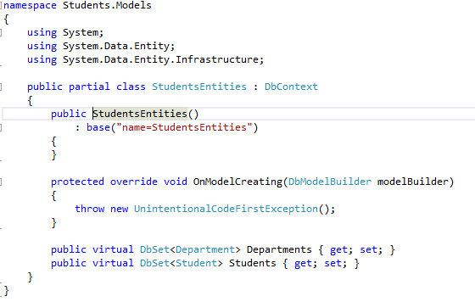

## Entity Framework uses DbContext, How is it different from Object Context?

DbContext can be used for code first while Object Context doesn’t. It exposes the most commonly used features of ObjectContext.

## What’s new in Entity Framework 6?

* Customizing Code First Conventions.
* Logging of database commands.
* Stored Procedure Mapping.
* Asynchroous Queries and Save support.

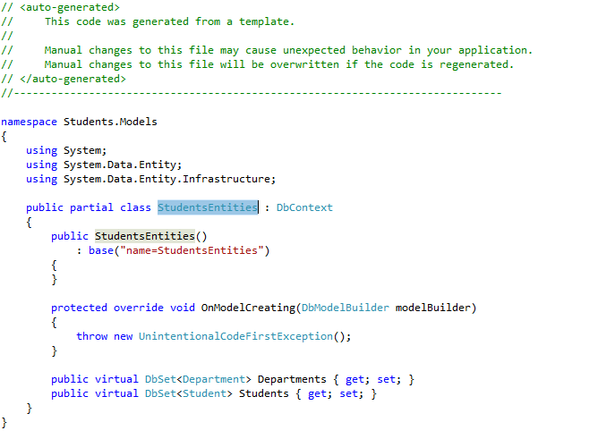

With EF6, in applications with lots of tables and relationships defined, our context objects open faster. We should also be better insulated from dropped connections (at least, if the drop is transient and not permanent — nothing is going to help there).  EF6 also generates SQL faster from LINQ queries than before (though it’s the same SQL that’s being generated as in earlier versions of EF, so your actual data access won’t be any faster or slower).

## Can we access a model in Entity Framework without primary key defined?

No, but we can access data.

Using Primary Key:

Student student = db.Students.Find(id);

Without Primary Key:

Student student = db.Students.Where(x=>x.StudentName==”Ahmad”);

## Why DB Context models object disposal is important in Entity Framework?

Until it’s disposed, it will be holding resources that aren’t in. If not disposed then Garbage collector will free the space but in some instance it holds up.

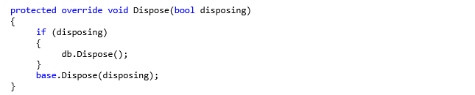

Calling dispose method to clear memory.

Can we do an insertion and deletion at the same block of code and then Apply save changes to them in a statement in Entity Framework?

Yes, WE CAN by using the below piece of code:

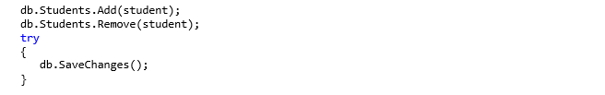

Here the student record will insert to db but not physically. When we call **SaveChanges** method then it actually insert in db and commit the transaction. If we delete before committing transaction nothing will change in database.

## What are the development approaches are supported in Entity Framework?

* Code First Approach – where code defines the database. Entity Framework handles creation.
* Database First Approach – regular approach used where database is first created or already exists.
* Model First Approach – where model is drawn first that further generate database scripts.

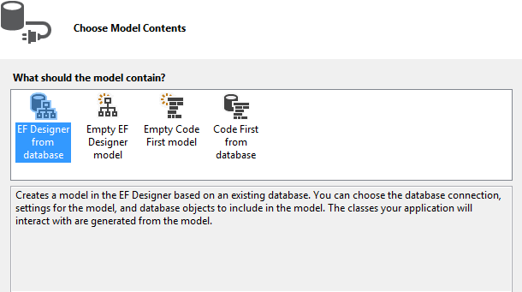

## What is the query syntax we use to query an ADO.NET Entity Data Model?

We can use LINQ to Query ADO.Net Entity Framework. For Example:

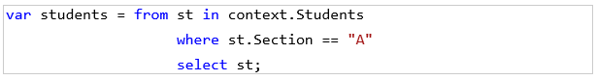

## Is LINQ a feature of Entity Framework?

Yes, following is the example to get student record from Section A.

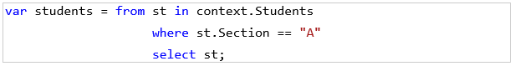

The same in Entity Framework:

Student student = db.Students.Where(x=>x.Section==”A”);

Does Default New Project Creation under Internet Template Category of ASP.NET MVC have any DB Context Ready while creating the project?

Yes, There is, as we can see in the below screenshot:

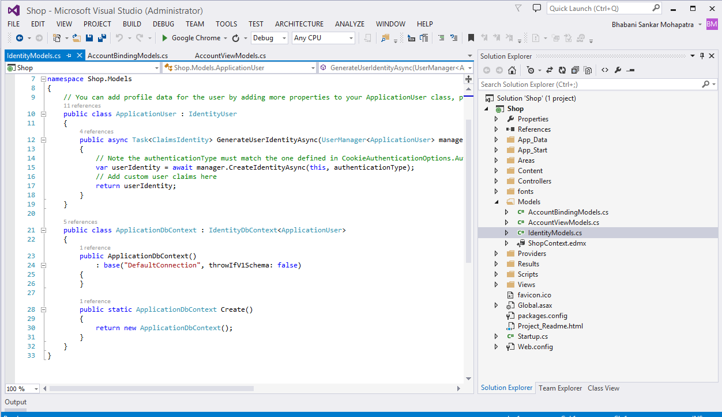

## If you provide the Primary Key value while inserting record to Entity Framework, will that execute fine, or will it throw an error while the adding statement?

Yes it will threw error if same a record present with same data. If identity is set then it will give error in any case.

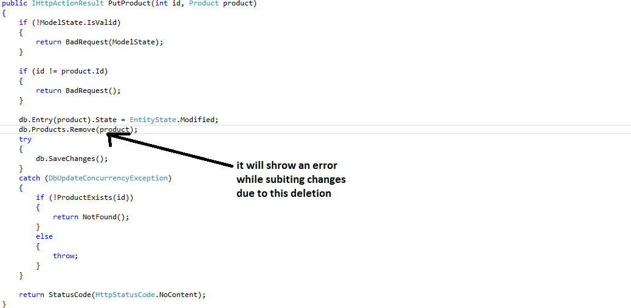

## What are the properties or Database Elements get copied in Dataset when Clone method is used?

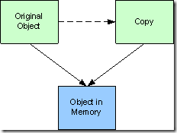

It will create a new object with same properties with a new instance.

## What is the role of a Self-Tracking Entities?

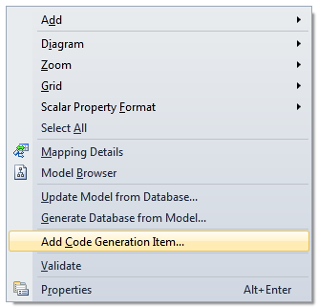

Self-tracking entity allows you to add code generated item:

## Can you describe the feature of split entity in Entity Framework?

Entity splitting gives us the ability to take an entity in our model and split this entity into multiple database tables. When we query an entity, Entity Framework will create a query that Automatically joins the related physical tables for us.

## What is the role of Entity Container in Entity Framework?

Entity container is a logical grouping of entity sets, association sets, and function imports.  The following must be true of an entity container defined in a conceptual model:

At least one entity container must be defined in each conceptual model.  The entity container must have a unique name within each conceptual model.

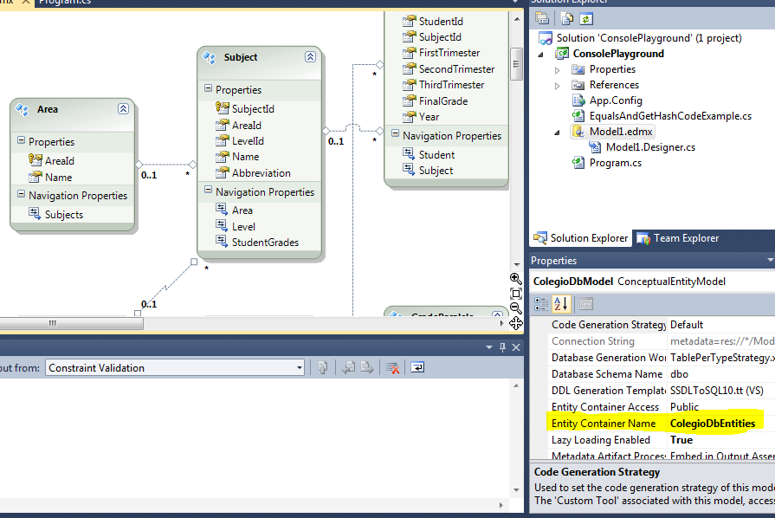

## Do we need to define any assembly references of entity framework if we use in web.config file?

Yes, that is necessary:

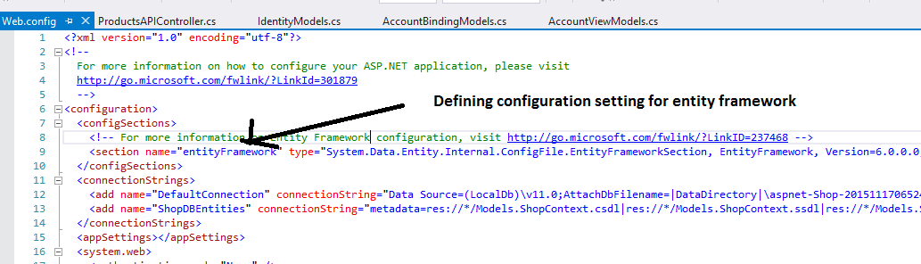

## Below is the difference table which defines each of the approaches. In Simple entity framework everything is auto generated and so you need the EDMX XML file as well. POCO is semi-automatic so you have full control on the entity classes but then the context classes are still generated by the EDMX file.

In code first you have complete control on how you can create the entity and the context classes. Because you are going to manually create these classes you do not have dependency on the EDMX XML file. Below is a simple table which shows the cross comparison.

|  |  |  |  |
| --- | --- | --- | --- |
|  | ***EDMX*** | ***Entity*** | ***Context*** |
| Simple entity framework | Needed | Auto | Auto |
| POCO approach | Needed | Manual | Manual |
| Code First | Not Needed | Manual | Manual |

Below is a great ADO.NET Entity framework interview question video created by [www.questpond.com](http://www.questpond.com/) which shows how to do CRUD using Entity framework.